Quantum Reservoir Computing (QRC) / Quantum Recurrent Models

1. Problem
Many machine learning tasks involve sequential, temporal, or dynamical data, such as time-series prediction, signal processing, and modeling physical systems. Classical approaches like Recurrent Neural Networks (RNNs) and Reservoir Computing (RC) are widely used for such problems.
Quantum Reservoir Computing (QRC) extends the reservoir computing paradigm to quantum systems, using the natural dynamics of a quantum system as a high-dimensional, non-linear reservoir for processing temporal data.

2. Intuition
The key idea of Quantum Reservoir Computing is:
- Use a fixed (untrained) quantum system as a reservoir
- Inject input data sequentially into the quantum system
- Exploit the rich quantum dynamics (superposition, entanglement, non-linearity via measurement)
- Train only a classical readout layer
Unlike variational models, the quantum circuit parameters are not optimized—only the classical post-processing is trained.

3. Circuit / System Structure
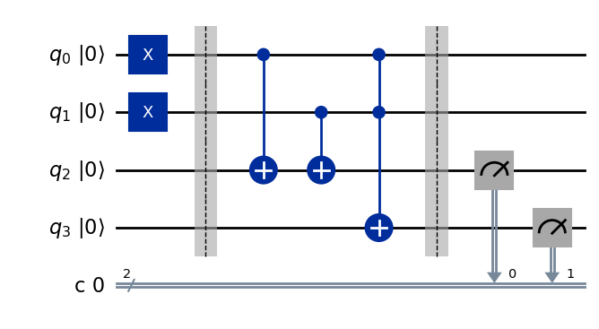
A QRC system typically consists of:
- Input Encoding
Time-dependent input data is injected into the quantum system via parameterized gates or Hamiltonian driving.
- Quantum Reservoir
A fixed quantum circuit or continuous-time quantum system evolves under its internal dynamics.
- Measurement
Observables are measured at each time step to generate reservoir states.
- Classical Readout
A classical linear model maps measurement outcomes to predictions.
High-level flow:
[ x(t) O(t) y(t) ]

4. Simple Math Involved
- Quantum state evolution: [ |(t+1)= U(x(t)) |(t) ]
- Measurement (reservoir state): [ r(t) = (t) | O | (t) ]
- Classical readout: [ y(t) = W^T r(t) ]
- Training objective: [ _W t |y(t) - y{}(t)|^2 ]
Only the classical weights (W) are trained.

5. Python Code (Quantum Reservoir Computing – Algorithm)
Platform-agnostic, educational implementation (conceptual QRC)
import numpy as np
T = 50
u = np.sin(np.linspace(0, 4 * np.pi, T))
target = np.roll(u, -1)
num_nodes = 10
np.random.seed(42)
W_res = np.random.randn(num_nodes, num_nodes)
W_in = np.random.randn(num_nodes)
state = np.zeros(num_nodes)
reservoir_states = []
for t in range(T):
state = np.tanh(W_res @ state + W_in * u[t])
reservoir_states.append(state)
reservoir_states = np.array(reservoir_states)
W_out = np.linalg.pinv(reservoir_states) @ target
predictions = reservoir_states @ W_out
print("Predictions (first 5):", predictions[:5])
This code mimics the reservoir computing principle. In a true QRC implementation, the reservoir states are obtained from quantum measurements.

6. Where the Algorithm Is Useful
- Time-series prediction
- Signal processing
- Dynamical system modeling
- Quantum control
- Learning from streaming data

7. Limitations
- Most implementations are theoretical or experimental
- Limited scalability on current hardware
- Noise sensitivity
- Difficult to benchmark quantum advantage
- Few standardized software tools

8. Comparison with Classical Reservoir Computing
- Reservoir: Classical RC uses nonlinear classical systems; QRC uses quantum dynamics
- Training: Both train only the readout layer
- Non-linearity: Quantum systems provide high-dimensional non-linear dynamics
- Maturity: Classical RC is mature; QRC is still experimental

9. One-Sentence Summary
Quantum Reservoir Computing processes temporal data by exploiting the natural dynamics of a fixed quantum system while training only a classical readout layer.

